Toolkit & Handouts
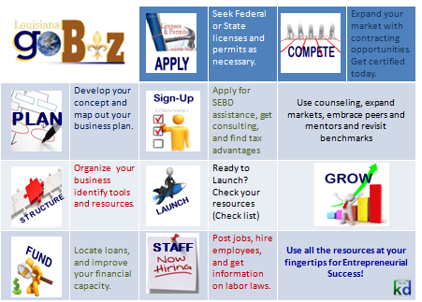
1
2
3
4
5

6

7

8

9

10

Entrepreneurial Development
From Start-up through Expansion

KISATCHIE-DELTA REGIONAL PLANNING & DEVELOPMENT DISTRICT
3516 PARLIAMENT COURT, ALEXANDRIA, LA 71303 kdelta@kricket.net 318-487-5454

BUSINESS PLAN OUTLINE
COVER SHEET |  | (Includes current contact information for organization)
STATEMENT OF PURPOSE |  | (include rationale for business plan and discussion of “ask”)
TABLE OF CONTENTS |  | (organizes your plan with page numbers for reviewer’s convenience)
EXECUTIVE SUMMARY |  | (includes highlights of each section and brief discussion of current undertakings)

THE BUSINESS
Overview of the Business | Generally explain: What is the business? What market do you intend to service? What is the size of the market, and what is your expected share? Why can you service that market better than your competition? Why have you chosen your particular location? What management and other personnel are required and available for the operation? Why will your investment or someone else’s money (debt/equity) make your business profitable?  Describe/respond to: What is the type of business: Is it primarily merchandising, manufacturing, or service? What is the nature of the product or service? How will this product or service be made/produced/ provided? How will it be sold? Who will buy it? What is the status of the business: start-up, expansion of a going concern, or a takeover of an existing business? What is the business structure: sole proprietorship, partnership, corporation, Sub Chapter S corporation? Who are the customers? Why is your business going to be profitable? When will (did) your business open? What hours and days of the week will you be in operation?  NOTE: If yours is a seasonal business, or if the hours will be adjusted seasonally, make sure that the seasonality is reflected in your replies to the two previous questions.  For a new business:  Why will you be successful in this business? What is your experience in this business? Have you spoken with other people in this kind of business? What was their response?

Market | Sales History of the Market  What are total sales of all manufacturers/providers of this product in dollars? In units? In percentage share of the market in dollars? In units? Same data on consumer purchases? How do geographical differences affect the share of the market held by various manufacturers? City size differences? Price differences? Seasonal differences?  Market Potential  What is the trend in use by consumers of related products? What is the trend in use by consumers of products which produce a need for this product? What is the trend in use by consumers of products which eliminate the need for this product? What statements have been made by authorities in this field about the future potential for this product? What new manufacturers are expected to enter this field? How do geographical differences affect the market for this product? Seasonal differences?  The Market  Who exactly is your market? Describe characteristics: age, sex, profession, income, etc., of your various market segments. What is the percent size of the market? What percentage of the market will you have? What is the market’s growth potential? As the market grows, does your share increase or decrease? How are you going to satisfy your market? How will you attract and keep this market? How can you expand your market? How are you going to price your service, product, or merchandise to make a fair profit, while being competitive? What price do you anticipate getting for your product? Is the price competitive? Why will someone pay your price? How did you arrive at the price? Is it profitable? What special advantages do you offer that may justify higher price? (You don’t have to engage in direct price competition.) Will you offer credit to your customers (accounts receivable)? If so, is this really necessary? Can you afford to extend credit? Can you afford bad debts?  Include a marketing plan.  Discuss publicity, marketing, advertising, branding, signage, and web presence.

Competition | Describe/respond to:  Who are your five nearest competitors? How will your operation be better than theirs? How is their business? Is it steady, increasing, or decreasing? Why? How are their operations similar and dissimilar to yours? What are their strengths and/or weaknesses? What have you learned from watching their operations?  How are you distinctive?
Operations (Manufacturing Plan) | OPERATIONS CHECKLIST  The operations plan should describe exactly how the business is going to operate. This may include flow charts, timetables, time-line continuums, etcetera. The objective is to make explicit the flow of activities through a business or any other activities required to deliver the product or service to the customer.  - What are the productive processes needed for the operation?  - What regular and special equipment is needed?  - Have subcontracting possibilities been fully explored? What are the cost implications?  - What special facilities are required to accommodate production needs?  - Are there particular considerations affecting the locations; such as space, layout, transportation access, other?  - Has the cost of components, plant equipment, and labor been carefully analyzed? Have alternatives been considered?  - What levels of inventories, raw material, work in process, and finished goods must be maintained? What are the costs of each?
Location | Describe/respond to:  What is your business address? What are the physical features of your building? Is your building leased or owned? State the terms. If renovations are needed, what are they? What is the expected cost? What is the neighborhood like (for example, stable, changing, improving, deteriorating)? Are there other special permits or licenses you may need? Does the zoning permit your kind of business? What kinds of businesses are in the area? Have you considered other areas? Why is this one the desirable site for your business? Why is this the right building and location for your business? How does this location affect your operating costs? Include any of the following that may be relevant.  - Amount of space needed; layout (diagram); type of construction; access; visibility; neighborhood; surrounding business; maps of local area.  - (OPTIONAL) As applicable, describe any components of your virtual presence/e-business. Describe your ‘presence’ and the percentage of your business as it relates to electronic commerce.
Management & Personnel | Organizational Chart.  - Include resumes. Include references.  - Show where credit and personal investigation checks have been conducted.  - Include an analysis of the management team; reputation, capabilities, and attitude. Discuss key management and personnel skills, roles, and responsibilities.  - Is the company innovative? Give specific details.  - Schedule of salaries and other compensation for management including bonuses and profit sharing plan.  - Outline stock options and profit-sharing plan.  - How are salary increases for management controlled.  - List directors not included in management and include their name, compensation, and shares of stock owned.  - Include any management contracts or contracts with consultants.

Record Keeping | Describe approaches, policies, controls, and records management for operations, such as: Accounts Receivable, Cash Management, Accounts Payable, Payroll, Personnel Policy, Pricing, Quality Control, Training, Credit, Inventory Control, Insurance,etc.
Risk Management | Explain risks, liabilities, and approaches to minimize.
Business Section Summary  (and description for effect of financing) | Elaborate on details of the business and identify the anticipated effect on loan/investment financing.  Describe: How is the loan or investment to be spent? This can be a general overview (for example, working capital, new equipment, inventory, and supplies). *Describe and list your use of funds, and support this with back-up documentation and/or references.  - What items will be purchased?  - What is the specific model name and/or number of your purchase?  - Who is the supplier?  - What is the price?  - What will you pay in sales tax, installation charges, and/or freight fees?  - How much will the loan or investment make your business more profitable?  - What is your equity injection amount and source?  - What is your intended collateral value and description? On what basis did you determine its value?
Development Schedule | Timeline

FINANCIAL DATA

Summary of Financial Needs

Sources and Applications of Funding

Capital Equipment List

Balance Sheet
Break-even Analysis: Break-even Point = Fixed Costs/(Unit Selling Price – Variable Costs)

FINANCIAL NOTES
- Financial documents.
- Describe accounting principles regarding depreciation, taxes, inventories, and so forth.
- If the business is seasonal, explain its cycle and describe your financing needs accordingly.
- List the aging of accounts receivable and accounts payable.
- Does the balance sheet contain hidden or undervalued assets or liabilities.
- Are all taxes paid?
- DISCLOSE PRIOR ISSUES AND HOW RESOLVED.
Income Projections (Profit and Loss Statements)
- Three-Year Summary
- Detail by Month (First Year)
- Detail by Quarter (Second and Third Years)
- Notes of Explanation
Pro-Forma Cash Flow
- Three-Year Summary
- Detail by Month (First Year)
- Detail by Quarter (Second and Third Years)
- Notes of Explanation
Historical Financial Reports for Existing Business
- Balance Sheets for Past Three Years
- Income Statements for Past Three Years
- Tax Returns

SUPPORTING DOCUMENTS | List documents and attach, include financials and, as appropriate, evidence of future revenues (summary and/or copy of contracts documenting basis of growth)

SUSTAINABILITY & SUCCESSION | Insert brief discussion on sustaining, growing, and exiting business, including mitigation of business interruptions, such as from disasters or market changes

BUSINESS NAME | PROFORMA CASH FLOW STATEMENT (TEMPLATE)
 | Expansion | Jan___ | Feb ___ | Mar ___ | Apr ___ | May ___ | Jun ___ | Jul ___ | Aug ___ | Sep ___ | Oct ___ | Nov ___ | Dec ___ | Year 1
 | Costs | Month 1 | Month 2 | Month 3 | Month 4 | Month 5 | Month 6 | Month 7 | Month 8 | Month 9 | Month 10 | Month 11 | Month 12 | TOTAL
Beg. Cash
Revenue from Sales
Loan
Equity
TOTAL CASH
COGS / Inventory
Fringe Benefits
Employee Payroll
Payroll Taxes
Property Taxes
Utilities
Telephone
Property Insurance
Advertising
Business/Wkmn's Comp. Insurance
Supplies
Professional Fees
License
Bank Charges
Travel & Entertain.
Furniture & Fixture
Office Equipment
Property Acquisition
Build-Out/Renovations
TOTAL EXPENSE
NET CASH OUTLAY
Loan -PROPOSED
SubTotal Loan Repayment
END CASH

(BUSINESS NAME) | PROFIT AND LOSS STATEMENT
 | YEAR 1 (_____) | YEAR 2 (_____) | YEAR 3 (_____)
GROSS RECEIPTS
COST OF SALES
GROSS PROFIT
OPERATING EXPENSES
Fringe Benefits
Employee Payroll
Payroll Taxes
Property Taxes
Utilities
Telephone
Property Insurance
Advertising
Business/Wkmn's Comp. Insurance
Supplies
Professional Fees
License
Bank Charges
Travel & Entertain.
Depreciation (1)
Interest (2)
TOTAL EXPENSES
NET INCOME
Debt Service (3)
Debt Coverage Ratio (4)
ASSUMPTIONS:
- Revenue increases by ____% in Year ___
- Most expenses increase by ___% in Year 2
(1) Depreciable items include: Property, Leasehold Improvements, Furniture & Fixtures and Office Equipment) . These items were depreciated over a 10-yr. straight line depreciation schedule which equates to an annual depreciation expense of $________ per year
(2) Interest expense is the actual interest paid on a $________ loan amortized over ____years at _______% interest; at an interest rate of _____% (multiplied by 12 months of the year) Monthly P&I of $______________*12 =$____________
(3) Debt Service is the monthly payment of principal and interest on the $__________ loan amortized over ___ years at an interest rate of ______% (multiplied by 12 months of the year) Monthly P&I of $_____________*12 =$________________
(4) Debt Coverage Ratio: Interest + Depreciation + Net Income/ Debt Service

BALANCE SHEET
(BUSINESS NAME)

ASSETS:
Current Assets:
 | Cash
 | Inventory
 | Account Receivable
Total Current Assets
 | Property & Improvements
 | Equipment
 | Furniture & Fixtures
 | Accumulated Depreciation
Total Property & Equipment
Other Assets
Total Assets |  | $
LIABILITIES
Current Liabilities
 | Accounts Payable
 | Notes Payable - new loan
Total Current Liabilities
Long Term Liabilities
 | Notes Payable - new loan
Total Long Term Liabilities
Total Liabilities |  | $
Equity:
 | Common Stock
 | Owner Equity
 | Retained Earnings
Total Equity/Net Worth |  | $
Total Liabilities and Equity |  | $

Business Information Snapshot
Complete this worksheet as an aid for applications for financing or business registrations, i.e., SEBD, Hudson Initiative, Sam.gov, or other.
Business Information
Name of Business:
*DBA [if applicable]:
Year established:
Contact Person: |  |  |  |  |  | Title of Contact Person:
Business Physical Address:
City: |  |  | State: |  |  |  | Zip code: |  |  |  |  | Parish:
Business Mailing Address:
City: |  |  | State: |  |  |  | Zip code: |  |  |  |  | Parish:
Phone: |  |  |  |  | Fax: |  |  |  |  | Email:
Web address: |  |  |  |  |  |  | Business FaceBook address:
Products or Services that Business sells or provides:
*NAICS:
Federal Tax ID No.: |  |  |  |  |  |  | State Tax ID No.:
Social Security No. [Sole Proprietorship, only]:
Business Structure:
Business Operations:
Number of Employees [including yourself]:
DUNS #
CCR #
SAM.gov |  | User name |  |  |  |  |  |  | Password
Other ______________ |  | User name |  |  |  |  |  |  | Password
Other ______________ |  | User name |  |  |  |  |  |  | Password
Business Bank Account |  |  |  |  |  |  |  |  | Routing #
Business Ownership Information
Name of Owner:
Home Address:
City: |  |  | State: |  |  |  | Zip code: |  |  |  |  | Parish:
Percent of Business Ownership:
Additional Owner(s) information [supply, same as above]:
Personal Net Worth [calculate Assets less Liabilities]
ASSETS - Note: When entering Assets, do not include retirement assets, personal residence, and assets of the business.
- Cash on hand and in banks |  |  |  |  |  |  |  | $
- Savings Account |  |  |  |  |  |  |  | $
- Stocks and Bonds |  |  |  |  |  |  |  | $
- Real Estate [other than personal residence] |  |  |  |  |  |  |  | $
- Automobile – Present value |  |  |  |  |  |  |  | $
- Other Assets |  |  |  |  |  |  |  | $
LIABILITIES - Note: When entering Liabilities, do not include the mortgage of your personal residence.
- Notes payable [Banks and Others] |  |  |  |  |  |  |  | $
- Installment Account [Auto] |  |  |  |  |  |  |  | $
- Credit Cards |  |  |  |  |  |  |  | $
- Real Estate Mortgages [other than personal residence] |  |  |  |  |  |  |  | $
- Other Liabilities |  |  |  |  |  |  |  | $
*Provide information for each and any individual/entity of 5% or greater ownership.
Business Assessment Snapshot
Current Total Business Assets |  |  |  |  |  |  |  | $
Current Total Business Net Worth (Assets less Liabilities) |  |  |  |  |  |  |  | $
Annual Gross Revenue for the past three years, listed by year individually |  |  |  |  |  |  |  | $  $  $
Business Net Profit (Loss) |  |  |  |  |  |  |  | $

OMB APPROVAL NO. 3245-0188
EXPIRATION DATE: 3/31/2008

PERSONAL FINANCIAL STATEMENT
U.S SMALL BUSINESS ADMINISTRATION As of (date)
Complete this form for: (1) each proprietor, or (2) each limited partner who owns 20% or more interest and each general partner, or (3) each stockholder owning 20% or more of voting stock, or (4) any other person or entity providing a guaranty on the loan.
Name |  |  |  |  |  |  |  |  | Business Phone
Residence Address |  |  |  |  |  |  |  |  | Residence Phone
City, State, & Zip Code
Business Name of Applicant/Borrower
ASSETS |  |  |  | (Omit Cents) |  |  | LIABILITIES |  |  |  |  | (Omit Cents)
Cash on hand & in Banks . . . . . . . . . . . . . . . . . |  |  |  |  |  |  | Accounts Payable . . . . . . . . . . . . . . . . . . .
Savings Accounts . . . . . . . . . . . . . . . . . . . . . . . |  |  |  |  |  |  | Notes Payable to Banks and Others . . . . .
IRA or Other Retirement Account . . . . . . . . . . |  |  |  |  |  |  | (Describe in Section 2)
Accounts & Notes Receivable . . . . . . . . . . . . . |  |  |  |  |  |  | Installment Account (Auto) . . . . . . . . . . . .  Mo. Payments
Life Insurance-Cash Surrender Value Only  (Complete Section 8) . . . . . . . . . . . . . . . . . . |  |  |  |  |  |  | Installment Account (Other) . . . . . . . . . . . .  Mo. Payments
Stocks and Bonds . . . . . . . . . . . . . . . . . . . . . .  (Describe in Section 3) |  |  |  |  |  |  | Loan on Life Insurance . . . . . . . . . . . . . . .
Real Estate . . . . . . . . . . . . . . . . . . . . . . . . . . . .  (Describe in Section 4) |  |  |  |  |  |  | Mortgages on Real Estate . . . . . . . . . . . .  (Describe in Section 4)
Automobile – Present Value . . . . . . . . . . . . . . . |  |  |  |  |  |  | Unpaid Taxes . . . . . . . . . . . . . . . . . . . . . .  (Describe in Section 6)
Other Personal Property . . . . . . . . . . . . . . . . . .  (Describe in Section 5) |  |  |  |  |  |  | Other Liabilities . . . . . . . . . . . . . . . . . . . . .  (Describe in Section 7)
Other Assets . . . . . . . . . . . . . . . . . . . . . . . . . . . |  |  |  |  |  |  | Total Liabilities . . . . . . . . . . . . . . . . . . . . . . |  |  |  |  | $0
(Describe in Section 5) |  |  |  |  |  |  | Net Worth . . . . . . . . . . . . . . . . . . . . . . . . . . |  |  |  |  | $0
Total |  |  |  | $0 |  |  | Total |  |  |  |  | $0
Section 1. Source of Income |  |  |  |  |  |  | Contingent Liabilities
Salary . . . . . . . . . . . . . . . . . . . . . . . . . . . . . . . . . . . |  |  |  |  |  |  | As Endorser or Co-Maker . . . . . . . . . . . . .
Net Investment Income . . . . . . . . . . . . . . . . . . . . |  |  |  |  |  |  | Legal Claims & Judgment . . . . . . . . . . . . .
Real Estate Income . . . . . . . . . . . . . . . . . . . . . . . |  |  |  |  |  |  | Provision for Federal Income Tax . . . . . . .
Other Income (Describe below)* . . . . . . . . . . . . . |  |  |  |  |  |  | Other Special Debt . . . . . . . . . . . . . . . . . .
Description of Other Income in Section 1.
*Alimony or child support payments need not be disclosed in “Other Income” unless it is desired to have such payments counted toward total income.
Section 2. Notes Payable to Bank and Others |  |  |  |  | (Use attachments if necessary. Each attachment must be identified as a part of this statement and signed.)
Name and Address of Noteholder(s) |  |  |  |  | Original  Balance | Current  Balance |  | Payment Amount | Frequency  (monthly, etc.) | How Secured or Endorsed  Type of Collateral
SBA Form 413 (3-05) Previous Editions Obsolete
Section 3. Stocks and Bonds |  |  |  |  | (Use attachments if necessary. Each attachment must be identified as a part of this statement and signed).
Number of Shares |  |  | Name of Securities |  |  |  |  | Cost |  | Market Value Quotation/Exchange |  |  |  |  | Date of Quotation/Exchange |  |  | Total Value
Section 4. Real Estate Owned. |  |  |  |  |  |  |  |  | (List each parcel separately. Use attachment if necessary. Each attachment must be identified as a part of this statement and signed.)
 |  |  |  |  |  |  |  |  | Property A |  |  |  |  | Property B |  |  | Property C
Type of Property
Address
Date Purchased
Original Cost
Present Market Value
Name & Address of Mortgage Holder
Mortgage Account Number
Mortgage Balance
Amount of Payment per Month/Year
Status of Mortgage
Section 5. Other Personal Property and Other Assets. |  |  |  |  |  |  |  |  |  |  |  | (Describe, and if any is pledged as security, state name and address of lien holder, amount of lien, terms of payment and if delinquent, describe delinquency)
Section 6. Unpaid Taxes. |  |  |  | (Describe in detail, as to type, to whom payable, when due, amount, and to what property, if any, a tax lien attaches.)
Section 7. Other Liabilities. |  |  |  |  |  | (Describe in detail.)
Section 8. Life Insurance Held. |  |  |  |  |  |  | (Give face amount and cash surrender value of policies – name of insurance company and beneficiaries)
I authorize SBA/Lender to make inquires as necessary to verify the accuracy of the statements made and to determine my creditworthiness. I certify the above and the statements contained in the attachments are true and accurate as of the stated date(s). These statements are made for the purpose of either obtaining a loan or guaranteeing a loan. I understand FALSE statements may result in forfeiture of benefits and possible prosecution by the U.S. Attorney General (Reference 18 U.S.C. 1001).
Signature: |  |  |  |  |  |  |  |  |  |  | Date: |  |  |  |  | Social Security Number:
Signature: |  |  |  |  |  |  |  |  |  |  | Date: |  |  |  |  | Social Security Number:
PLEASE NOTE: |  | The estimated average burden hours for the completion of this form is 1.5 hours per response. If you have questions or comments  concerning this estimate or any other aspect of this information, please contact Chief, Administrative Branch, U.S. Small Business  Administration, Washington, D.C. 20416, and Clearance Officer, Paper Reduction Project (3245-0188), Office of Management and Budget,Washington, D.C. 20503. PLEASE DO NOT SEND FORMS TO OMB.
SBA Form 413 (3-05) Previous Editions Obsolete

SECRETARY OF STATE - GEAUXBIZ
Online tool for accessing and identifying needed professional licenses/certifications and business permitting…
https://geauxbiz.sos.la.gov/
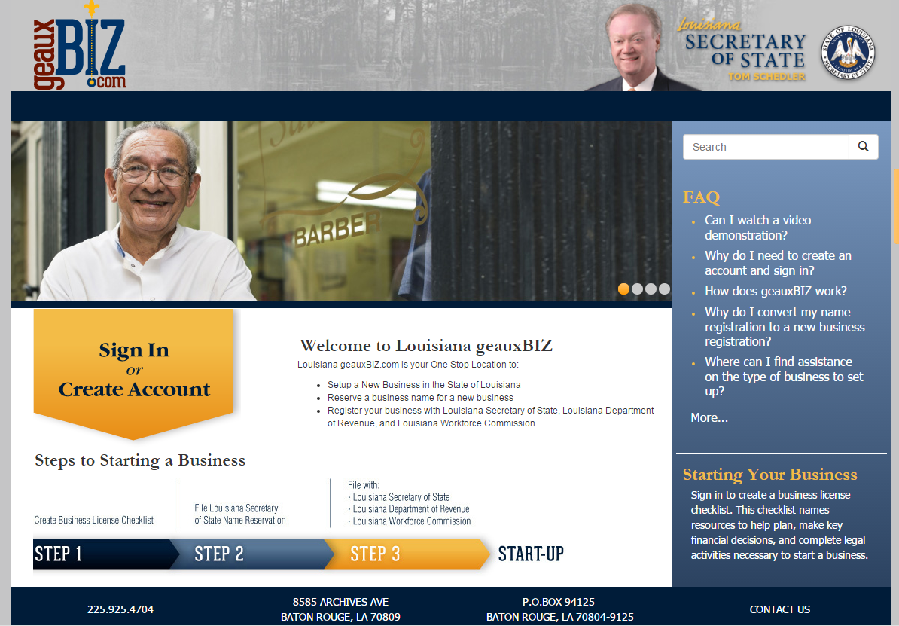

SYSTEM FOR AWARD MANAGEMENT
Gather your business information and NAICS code to prepare for doing business with the government, as a contractor, subcontractor, borrower, etc.
http://www.census.gov/eos/www/naics/
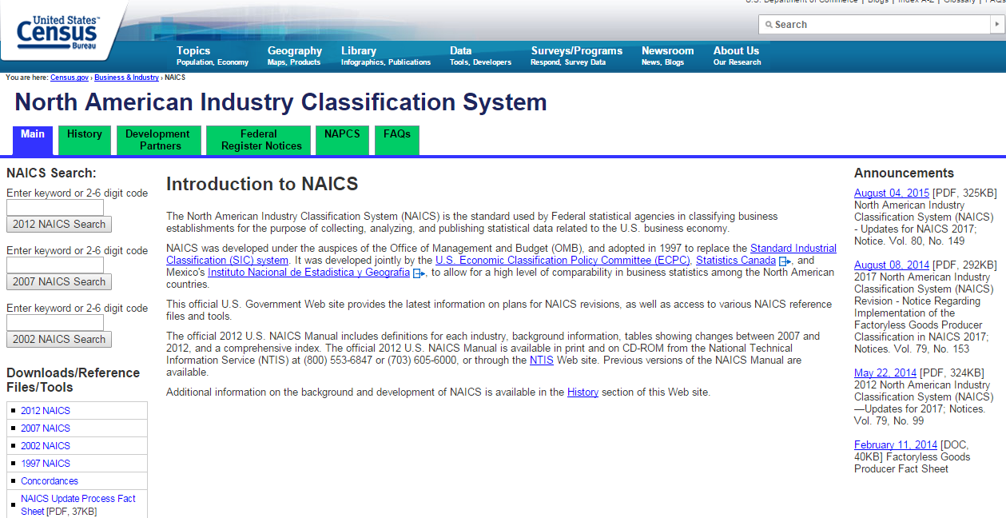

REGISTER FOR SAM.GOV at this online address:
https://uscontractorregistration.com/sam-registration/?gclid=Cj0KCQjwrZLdBRCmARIsAFBZllFE4JzED-vrBFoJmcK8YpWzJYLMz6uejjRr50XOk4CwmYW0BHBE3mgaAqhJEALw_wcB

FAST-START
Customized workforce training solutions, the #1 program in the nation.

SMALL & EMERGING BUSINESS DEVELOPMENT
Third-party assistance to leverage your investment in non-tangibles such as managerial training, accounting and finance solutions, marketing and creative…Also check out the Hudson Initiative.

INCENTIVES (FastLane)
Enterprise Zone, Industrial Tax Exemption, Restoration Tax Abatement, Quality Jobs. Can you see a partial abatement, credit or rebate?

ARE YOU READY TO LAUNCH? ARE YOU IN BUSINESS?
- Business plan -- that you write.
- Your business' legal structure is defined. (Incorporation documents)
- Identify your location and comply with laws/permits. (Zoning, etc.)
- Are you set up? Register/file with Louisiana Secretary of State. (Commercial database)
- Get a federal tax ID from the Internal Revenue Service. (FIN/TIN/EIN)
- Register with LDR for tax account. Register for business license. Register for sales/use tax account.
- Identify permits specific to your business...day care, florist, environmental.
Geauxbiz has a wizard; USE IT.
- Separate bank account is established in business name.
- Embrace employer responsibilities. Register with the Louisiana Workforce Commission. Set up to pay unemployment insurance. Obtain workers' compensation insurance. Explore employer's handbook.

BUSINESS SERVICES WITH LAWORKS.NET
Locate staff.
Request assistance “filtering” applicants.
Participate in a job fair.
Apply for job training resources.
Access the “Employer’s Handbook.”
Find qualified and productive human resources.
Obtain information on Louisiana Job Connection (Louisiana Economic Development).

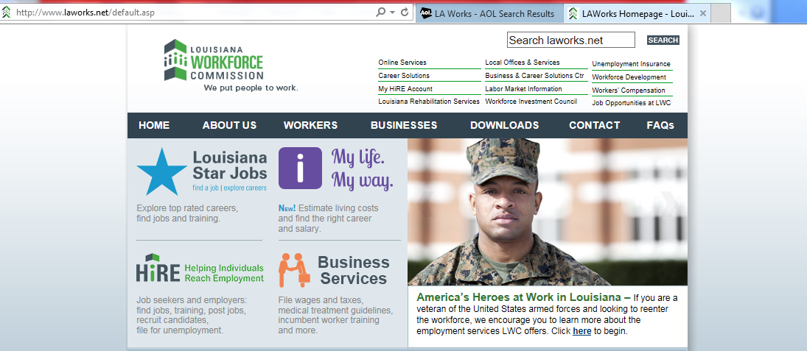

REGISTER WITH WWW.LAWORKS.NET and USE “HIRE!”
7

COMPANY REGISTRATION/UPDATE
BASIC INFORMATION – Enter your “business card” information and supply basic information.
Date Submitted: / / | Contact Person: |  |  | Title:
Company: |  |  | Registered Name in HIRE (LAVOS):
Mailing Address: |  |  |  | Phone:
Physical/Worksite Address: |  |  |  | Fax:
Email Address: |  |  |  | Website:
Major products/services: |  | NAICS: |  | DUNS#/SAMS#:
 |  | Federal Tax ID: |  | Unemployment Insurance #:
Female-owned Minority-owned Government Private Public Non-profit Veteran-owned
Set your login access.
USER NAME: |  |  | Use a combination of 4-20 letters and numbers.
PASSWORD: | Use 8-20 case-sensitive characters, including 1 uppercase, 1 lowercase, 1 number and 1 special character:
PRIVACY -- Choose your question and enter a customized response.
Security – SELECT ONE Question to answer:  What is your Mother’s maiden name? What is your pet’s name?  What is the name of your first school? Who was your childhood hero?  What is your favorite pastime? What is your all-time favorite sports team?  What is your father’s middle name? What was your high school mascot?  What was the make of your first car or bike?  Where did you first meet your spouse? Where were you born? |  | Custom Response Answer:  FOR CLIENT USE ONLY.
Description and Benefits
Current Number of Employees: | Company Profile:
Desired Number of Employees:
Current Job Vacancies to Post? Yes No
Benefits Offered:
Medical Dental Vision
Vacation Sick Leave Holidays
Retirement/Pension 401-K
Stock options Life Insurance
Uniform Allowance Tuition Assistance
Child Care Job Share Flex-time
Company Vehicle Relocation Assistance
Other:
Employer Type:
Private Sector State Gov’t Local Gov’t
Federal Gov’t Non-profit Int’l Gov’t.
Education (higher) Education (K-12)
Are you a Federal Contractor: Yes No
What other hiring/training needs exist or are project?
MARK items of interest.
Louisiana Enterprise Zone or other tax incentive programs.  Training programs and assistance to improve your workforce.  Appointment with Business Services to discuss options, resources or concerns.  Free OSHA Consultation to assess workplace safety.  Post a Job Vacancy, get help with a job description or seek employer-based training.  Learn about being a WorkReady business using WorkKeys assessments to measure existing or new employees. | FEEDBACK: FOR CLIENT USE ONLY.

OTHER INSTRUCTIONS:

PREPARING A JOB PROFILE …

Date Prepared/Revised: / / | Contact Person: |  | Title:
Company: |  | Registered Name in HIRE (LAVOS):
Mailing Address: |  |  | Phone:
Physical/Worksite Address: |  |  | Fax:
Email Address: |  |  | Website:
Major products/services: |  | NAICS: |  | DUNS#/SAMS#:
 |  | Federal Tax ID: |  | Unemployment Insurance #:
Female-owned Minority-owned Government Private Public Non-profit Veteran-owned
JOB VACANCY TO POST
Job Title |  |  |  |  |  |  |  |  | Number of Openings  # ________________  Maximum number of applicants to refer.  # ________________ |  | Display in HIRE at www.laworks.net  online to jobseekers suppress  show company name  have BCSC staff screen applicants
Job Occupation
Location of this job |  |  |  | Employer size?  (current # employees) |  |  |  |  | / / Earliest Date to Display  / / Latest Date to Display
Type of Job |  |  |  | Hours/Duration |  |  |  |  | Hiring Requirements
Regular  Temporary  Seasonal | Contract  Volunteer  None selected |  |  | Full-time  Part-time  PRN |  | 150+ days  4-150 days  1-3 days |  |  | Drug Testing/Screening Background Checks Credit Checks
 |  |  |  |  |  |  |  |  | Reference Checks Motor Vehicle Check Other (describe):
Test requirement By employer By BCSC None
Mark if WorkKeys required. SELECT MINIMUM LEVEL .
Bronze Silver Gold Platinum
JOB DESCRIPTION Abbreviated description below. SEE ATTACHED. REQUEST WORKFORCE OFFICE FOLLOW-UP/ASSISTANCE
SKILLS DESCRIPTION Use default Do not define REQUEST WORKFORCE OFFICE FOLLOW-UP/ASSISTANCE
Selected skills (describe):
Minimum Age, Experience &  Education |  | Age? |  |  |  |  |  | Months’ experience? |  | Education? (List required.) GED? Diploma? Degree?
 |  | Reason for Age Requirement?
Accessible by Public Transportation? Yes No |  |  |  |  | Driver’s License: None Commercial Operators  List class/endorsements:
MIN. salary $ . |  |  | MAX. salary $ . |  |  |  |  | Depends on Experience (DOE) |  |  |  | BENEFITS OFFERED: Medical Dental Vacation Sick Leave Retirement Other: (describe)
Hour Day Month Quarter Annual |  |  |  |  |  | Supplemental Compensation Yes No
Hours per week Not Specified Vary Specific |  |  |  |  |  | Shift Day Evening Night Rotating Split Other (see job description) NA
APPLICATION METHODS ACCEPTED: HIRE Resume Online (recommended) HIRE application Via email: Mail Fax Phone In Person At BCSC Via Company Website
DESCRIBE DESIRED PROCESS, INCLUSIVE OF SCREENING:  Allow notification as job seeker makes online application  Upload to US Jobs OTHER: |  |  |  |  |  |  | Other Applicant Information Required Contact Information  Employment History Education History Certifications  Desire Job Type (work hours/shift, travel percent, etc.)  Allow individuals without experience, i.e., college graduates
 |  |  |  |  |  |  | Mark ,if applicable: Green Job Federal Contractor Enterprise Zone Required post by court-ordered affirmative action plan For H-2B temporary non-agricultural guest worker in U.S.

OTHER INSTRUCTIONS:

GOVERNMENT CONTRACTING CAN BE YOUR EXPANDED MARKET.

Can you deliver for a prime contractor? A federal agency small purchase? A state agency consulting? A municipal contract?
CONSIDER your credibility and performance and opportunity to be a purchased service and/or product needed by the public sector.

Louisiana vendor list
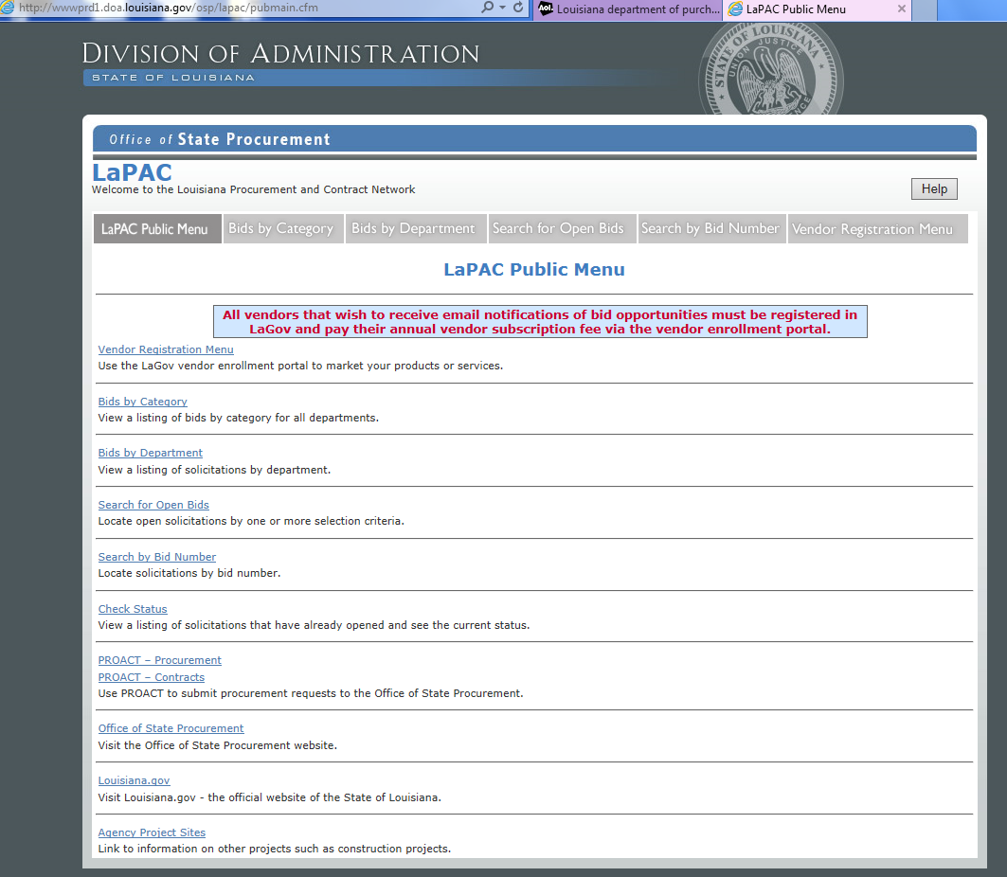

FedBizOpps: Look for your next opportunity!
https://www.fbo.gov/
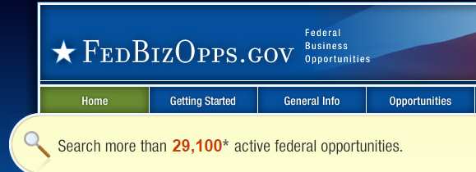

CONNECT AND COMPETE.

By leveraging the assets within your region or in others, you can deliver greater value and opportunities for innovation within your own company.
DO YOU KNOW YOUR REGION?

- Chamber?
- Trade Groups?
- Rotary?
- Kiwanis/
- SBDC?
- Who else?
- Ag Center?
- Lenders?
- PTAC?

ARE YOU ENGAGED?

- Economic Gardening?
- Leadership programs?
- Community initiatives?
- CEO Roundtables?

PLUG IN!

- Can you donate time to a companion volunteer effort?
- Do you mentor?
- Are you values cross-cutting from personal to business?

REGIONAL ECONOMIC COMPETITIVENESS.
Small business is BIG for our regional economy. Your stability may very well depend on your business’ adaptability to disruptions, whether recession or natural disaster. Locate “how” to find resources that help you manage and navigate.

RESILIENCY IS COMPETITIVENESS.
Continuity and mitigation. What happens if…
- Business Continuity Plan Methodology
The business continuity plan (BCP) should identify actions that organizations should take to minimize the adverse effects of potential disasters. Specifically, the organization’s BCP should include a preventive program that supports a documented BCP strategy, a comprehensive BCP framework, a testing program, and an oversight program to ensure that the plan is reviewed and updated regularly. Most organizations implement a phased methodology to analyze potential areas of vulnerability, define viable strategies, and implement business continuity plans.
- ARE YOU READY? Visit READY.GOV.

- Do you have a back-up? Who takes over? How do you adapt?

REGIONAL ECONOMIC DEVELOPMENT DISTRICT.
Established in 1967, we are conveners, connectors, and capacity builders.

- For small business, we help connect entrepreneurs with resources, understand lending, and access registrations and training opportunities.
- As conveners, we bring together peer-resources and leaders to coordinate, collaborate, and create a collective impact for an ecosystem that enhances business climate growth.
- As connectors, we bring entrepreneurs, lenders, investors, and partners together to cultivate growth and expansion.
- As capacity builders, we create and deliver tools, resources, and programs to help entrepreneurs face challenges.

We believe the backbone of our region is the small businesses we work with on a daily basis. It is our goal to help their growth and expansion in as many ways as we possibly can.
318-487-5454

Also visit KISATCHIE-DELTA REGIONAL PLANNING & DEVELOPMENT DISTRICT online at:

www.kdelta.org

